**Task 7: Highest sum of consecutive integers**

**Code:**

*#This program finds the consecutive integers which makeup the highest sum*

*li=[1,3,5,7,4,6,0,9,2,8]*

*print(li)*

*n=int(input("Enter the number of consecutive terms:"))*

*numbers=[]*

*indexes=[]*

*def con(n,li):*

*max=0*

*for i in range(0,len(li)):*

*sum=0*

*indexes.clear()*

*if i<=len(li)-n:*

*for j in range(i,i+n):*

*sum+=li[j]*

*indexes.append(j)*

*if sum>max:*

*max=sum*

*numbers.clear()*

*for i in indexes:*

*numbers.append(li[i])*

*print(numbers)*

*con(n,li)*

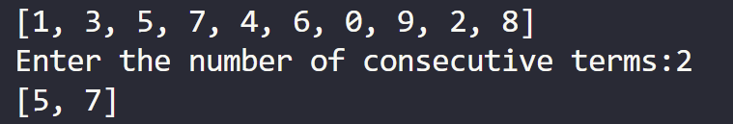**OUTPUT:**

